PRACTICAL-06

Objective - Write a program that copies content of one file to another. Pass the names of the files through command-line arguments.

Code –

package Dhruv_Java; import java**.**io**.\***; import java**.**util**.\***; **class** filecopy {

**public static void** main(String arg[]) **throws** Exception { Scanner sc = new Scanner(System.in); System.out.print("Provide source file name :");

String sfile = sc.next();

System.out.print("Provide destination file name :"); String dfile = sc.next();

FileReader fin = new FileReader(sfile); FileWriter fout = new FileWriter(dfile, true); **int** c;

while ((c = fin.read()) != -1) { fout.write(c);

}

System.out.println("Copy from "+sfile+" to"+dfile); fin.close();

fout.close();

sc.close();

}

}

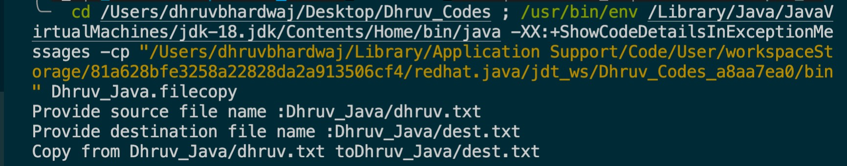OUTPUT:-